**VISVESVARAYA TECHNOLOGICAL UNIVERSITY**

**“JnanaSangama”, Belgaum -590014, Karnataka.**



**LAB REPORT**

**On**

**ANALYSIS AND DESIGN OF ALGORITHMS (23CS4PCADA)**

**Submitted by**

**Subramanya J (1BM23CS343)**

**in partial fulfillment for the award of the degree of**

**BACHELOR OF ENGINEERING**

**in**

**COMPUTER SCIENCE AND ENGINEERING**



**B.M.S. COLLEGE OF ENGINEERING**

**(Autonomous Institution under VTU)**

**BENGALURU-560019**

**February-May 2025**

**B. M. S. College of Engineering,**

**Bull Temple Road, Bangalore 560019**

**(Affiliated To Visvesvaraya Technological University, Belgaum)**

**Department of Computer Science and Engineering**



This is to certify that the Lab work entitled **“ANALYSIS AND DESIGN OF ALGORITHMS”** carried out by Subramanya J **(1BM23CS343)**, who is bonafide student of **B. M. S. College of Engineering**. It is in partial fulfillment for the award of **Bachelor of Engineering in Computer Science and Engineering** of the Visvesvaraya Technological University, Belgaum during the year 2024-25. The Lab report has been approved as it satisfies the academic requirements in respect of Analysis and Design of Algorithms Lab - **(23CS4PCADA)** work prescribed for the said degree.

**Dr. Sarala D V** **Dr. Kavitha Sooda**

Assistant Professor Professor and Head

Department of CSE Department of CSE

BMSCE, Bengaluru BMSCE, Bengaluru

**Index Sheet**

|  |  |  |
| --- | --- | --- |
| **Sl.**  **No.** | **Experiment Title** | **Page No.** |
| 1 | Write program to obtain the Topological ordering of vertices in a given digraph.  LeetCode Program related to Topological sorting | 5 |
| 2 | Implement Johnson Trotter algorithm to generate permutations. | 8 |
| 3 | Sort a given set of N integer elements using Merge Sort technique and compute its time taken. Run the program for different values of N and record the time taken to sort.  LeetCode Program related to sorting. | 11 |
| 4 | Sort a given set of N integer elements using Quick Sort technique and compute its time taken.  LeetCode Program related to sorting. | 15 |
| 5 | Sort a given set of N integer elements using Heap Sort technique and compute its time taken. | 19 |
| 6 | Implement 0/1 Knapsack problem using dynamic programming.  LeetCode Program related to Knapsack problem or Dynamic Programming. | 22 |
| 7 | Implement All Pair Shortest paths problem using Floyd’s algorithm.  LeetCode Program related to shortest distance calculation. | 25 |
| 8 | Find Minimum Cost Spanning Tree of a given undirected graph using Prim’s algorithm.  Find Minimum Cost Spanning Tree of a given undirected graph using Kruskal’s algorithm. | 28 |
| 9 | Implement Fractional Knapsack using Greedy technique.  LeetCode Program related to Greedy Technique algorithms. | 34 |
| 10 | From a given vertex in a weighted connected graph, find shortest paths to other vertices using Dijkstra’s algorithm. | 37 |
| 11 | Implement “N-Queens Problem” using Backtracking. | 40 |

**Course outcomes:**

|  |  |
| --- | --- |
| CO1 | Analyze time complexity of Recursive and Non-recursive algorithms using asymptotic notations. |
| CO2 | Apply various design techniques for the given problem. |
| CO3 | Apply the knowledge of complexity classes P, NP, and NP-Complete and prove certain problems are NP-Complete |
| CO4 | Design efficient algorithms and conduct practical experiments to solve problems. |

**Lab program 1:**

**Write program to obtain the Topological ordering of vertices in a given digraph.**

**#include <stdio.h>**

**#include <stdlib.h>**

**#include "graph.h"**

**#define MAX 100**

**void topological_sort(int **adj, int n) {**

**int in_degree[MAX] = {0};**

**int *order = malloc(n * sizeof(int));**

**int index = 0;**

**for (int i = 0; i < n; i++)**

**for (int j = 0; j < n; j++)**

**if (adj[i][j] != 0)**

**in_degree[j]++;**

**int stack[MAX], top = -1;**

**for (int i = 0; i < n; i++)**

**if (in_degree[i] == 0)**

**stack[++top] = i;**

**while (top != -1) {**

**int u = stack[top--];**

**order[index++] = u;**

**for (int v = 0; v < n; v++) {**

**if (adj[u][v] != 0) {**

**in_degree[v]--;**

**if (in_degree[v] == 0)**

**stack[++top] = v;**

**}**

**}**

**}**

**if (index != n) {**

**printf("Cycle detected. Topological sorting not possible.\n");**

**} else {**

**printf("Topological order: ");**

**for (int i = 0; i < n; i++)**

**printf("%d ", order[i]);**

**printf("\n");**

**}**

**free(order);**

**}**

**int main() {**

**int n, e;**

**int **graph = graph_create(&n, &e);**

**topological_sort(graph, n);**

**for (int i = 0; i < n; i++)**

**free(graph[i]);**

**free(graph);**

**return 0;**

**}**

**Ouput :**

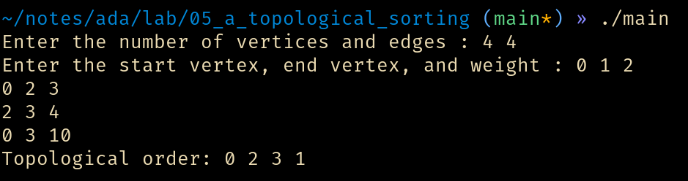

**LeetCode 207: Course Schedule**

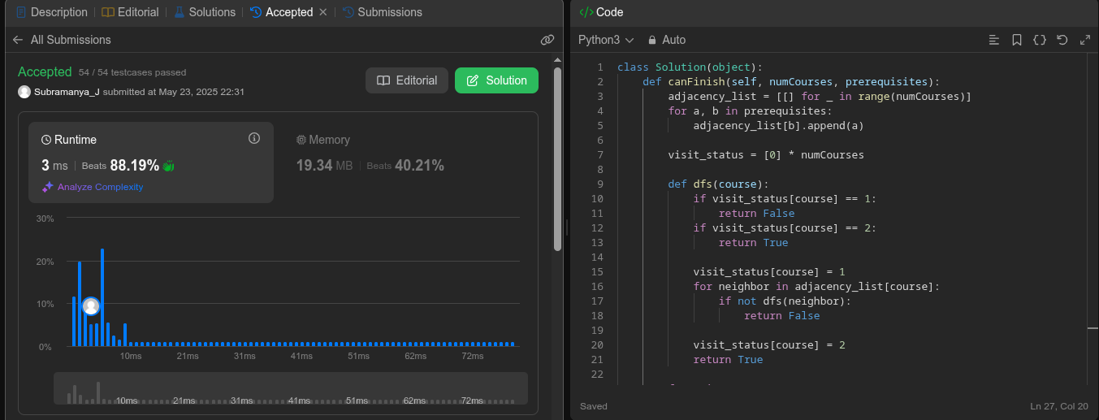

**Lab program 2:**

Implement Johnson Trotter algorithm to generate permutations.

#include <stdio.h>

#include <stdlib.h>

#define L -1

#define R 1

typedef struct { int v, d; } E;

void p(E *a, int n) {

for (int i = 0; i < n; i++) printf("%d ", a[i].v);

printf("\n");

}

int lm(E *a, int n) {

int m = -1, lv = -1;

for (int i = 0; i < n; i++) {

int adj = i + a[i].d;

if (adj >= 0 && adj < n && a[i].v > a[adj].v && a[i].v > lv) {

lv = a[i].v;

m = i;

}

}

return m;

}

void rd(E *a, int n, int v) {

for (int i = 0; i < n; i++) if (a[i].v > v) a[i].d *= -1;

}

void jt(int n) {

E *a = malloc(n * sizeof(E));

for (int i = 0; i < n; i++) { a[i].v = i + 1; a[i].d = L; }

p(a, n);

while (1) {

int idx = lm(a, n);

if (idx == -1) break;

int d = a[idx].d, si = idx + d;

E t = a[idx]; a[idx] = a[si]; a[si] = t;

rd(a, n, a[si].v);

p(a, n);

}

free(a);

}

int main() {

int n;

printf("Enter the number of elements to permute: ");

scanf("%d", &n);

jt(n);

return 0;

}

Ouput :

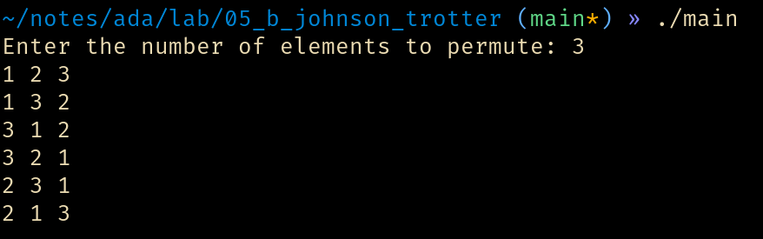

**Lab program 3:**

Sort a given set of N integer elements using Merge Sort technique and compute its time taken. Run the program for different values of N and record the time taken to sort.

#include <stdio.h>

#include <time.h>

#include <stdlib.h>

#define MAX 1000

void merge(int *arr, int left, int mid, int right) {

int i, j, k;

int n1 = mid - left + 1;

int n2 = right - mid;

int *L = (int *) malloc(n1 * sizeof(int));

int *R = (int *) malloc(n2 * sizeof(int));

for (i = 0; i < n1; i++)

L[i] = arr[left + i];

for (j = 0; j < n2; j++)

R[j] = arr[mid + 1 + j];

i = 0;

j = 0;

k = left;

while (i < n1 && j < n2) {

if (L[i] <= R[j]) {

arr[k] = L[i];

i++;

} else {

arr[k] = R[j];

j++;

}

k++;

}

while (i < n1) {

arr[k] = L[i];

i++;

k++;

}

while (j < n2) {

arr[k] = R[j];

j++;

k++;

}

free(L);

free(R);

}

void mergeSort(int *arr, int left, int right) {

if (left < right) {

int mid = left + (right - left) / 2;

mergeSort(arr, left, mid);

mergeSort(arr, mid + 1, right);

merge(arr, left, mid, right);

}

}

void sortArray(int *arr, int size) {

mergeSort(arr, 0, size - 1);

printf("\n\n");

}

void printArray(int *arr, int size) {

for (int i = 0; i < size; i++)

printf("%d ", arr[i]);

}

int main() {

int max = MAX;

int *arr, size;

printf("Enter the size of the array : ");

scanf("%d", &size);

arr = malloc(size*sizeof(int));

printf("Enter the elements : \n");

for(int j = 0; j < size; j++) {

scanf("%d", &arr[j]);

}

printf("Given array is\n");

printArray(arr, size);

sortArray(arr, size);

printf("\nSorted array is \n");

printArray(arr, size);

return 0;

}

Output :

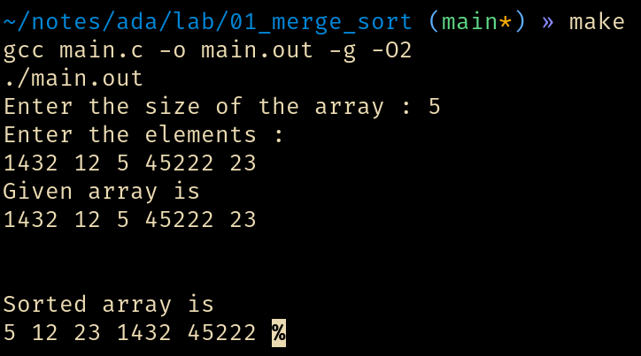

**LeetCode 15: 3Sum**

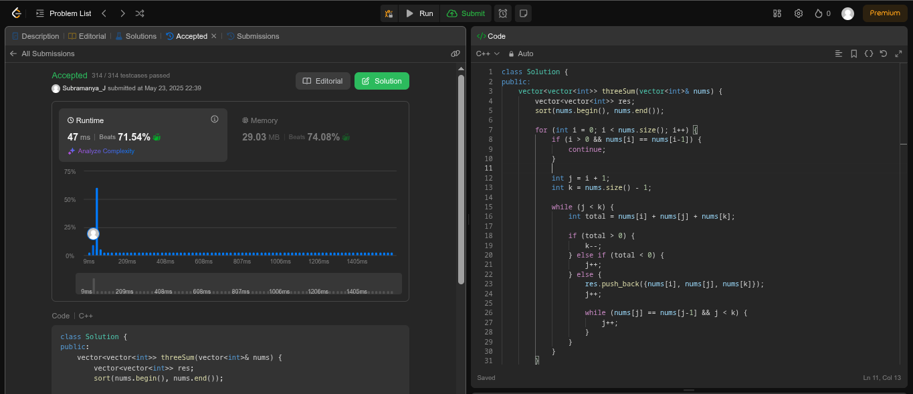

**Lab program 4:**

**Sort a given set of N integer elements using Quick Sort technique and compute its time taken.**

**// quick_sort.c**

**#include <stdio.h>**

**#include <stdlib.h>**

**#include <time.h>**

**#define MAX 5**

**void quick_sort(int *arr, int low, int high);**

**int partition(int *arr, int low, int high);**

**void swap(int *a, int *b);**

**int temp;**

**void quick_sort(int *arr, int low, int high) {**

**if(low >= high) {**

**return;**

**}**

**int p_index = partition(arr, low, high);**

**quick_sort(arr, low, p_index - 1);**

**quick_sort(arr, p_index + 1, high);**

**}**

**int partition(int *arr, int low, int high) {**

**int pivot = arr[(low + (high - low) / 2)];**

**int i = low - 1;**

**for(int j = low; j < high; j++) {**

**if(arr[j] <= pivot) {**

**swap(&arr[++i], &arr[j]);**

**}**

**}**

**swap(&arr[i+1], &arr[high]);**

**return i + 1;**

**}**

**void swap(int *a, int *b) {**

**temp = *a;**

**\*a = *b;**

**\*b = temp;**

**}**

**void display_array(int *arr, int size) {**

**putchar('\n');**

**for (int i = 0; i < size; i++) {**

**printf("%d ", arr[i]);**

**}**

**putchar('\n');**

**}**

**int main() {**

**int max = MAX;**

**clock_t start, end;**

**FILE *fp = fopen("data.txt", "w");**

**for(int i = 1; i <= max; i++) {**

**// printf("%d elements\n", i);**

**int *arr, size = i;**

**// printf("Enter the size of the array : ");**

**// scanf("%d", &size);**

**arr = malloc(size*sizeof(int));**

**// printf("Enter the elements : \n");**

**for(int j = 0; j < size; j++) {**

**// scanf("%d", &arr[j]);**

**arr[j] = rand();**

**}**

**// printf("\n------------------------------------\n\nSize : %d\n", i);**

**printf("Given array is\n");**

**display_array(arr, size);**

**start = clock();**

**quick_sort(arr, 0, size-1);**

**end = clock();**

**printf("\nSorted array is \n");**

**display_array(arr, size);**

**fprintf(fp, "%d, %d\n", (int) (end - start), i);**

**}**

**fclose(fp);**

**return 0;**

**}**

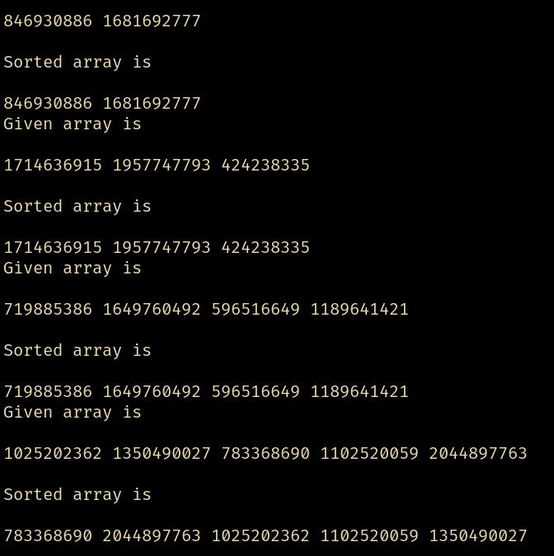**Output :**

**LeetCode 912: Sort an Array**

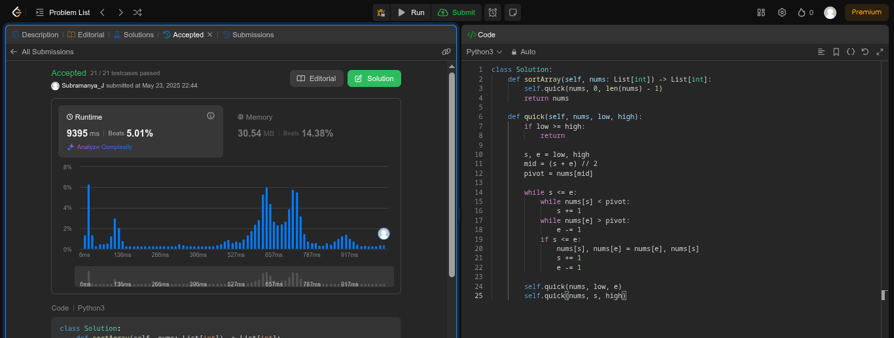

**Lab program 5:**

**Sort a given set of N integer elements using Heap Sort technique and compute its time taken.**

**#include <stdio.h>**

**void heapify(int arr[], int n, int i) {**

**int largest = i;**

**int left = 2 * i + 1;**

**int right = 2 * i + 2;**

**if (left < n && arr[left] > arr[largest]) {**

**largest = left;**

**}**

**if (right < n && arr[right] > arr[largest]) {**

**largest = right;**

**}**

**if (largest != i) {**

**int temp = arr[i];**

**arr[i] = arr[largest];**

**arr[largest] = temp;**

**heapify(arr, n, largest);**

**}**

**}**

**void heapSort(int arr[], int n) {**

**for (int i = n / 2 - 1; i >= 0; i--) {**

**heapify(arr, n, i);**

**}**

**for (int i = n - 1; i >= 0; i--) {**

**int temp = arr[0];**

**arr[0] = arr[i];**

**arr[i] = temp;**

**heapify(arr, i, 0);**

**}**

**}**

**int main() {**

**int n;**

**printf("Enter the number of elements : ");**

**scanf("%d", &n);**

**int arr[n];**

**printf("Enter the elements : ");**

**for(int i = 0; i < n; i++) {**

**scanf("%d", &arr[i]);**

**}**

**heapSort(arr, n);**

**printf("Sorted array: \n");**

**for (int i = 0; i < n; i++) {**

**printf("%d ", arr[i]);**

**}**

**return 0;**

**}**

**Output :**

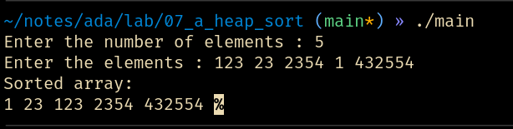

**Lab program 6:**

**Implement 0/1 Knapsack problem using dynamic programming.**

**#include <stdio.h>**

**int max(int a, int b) {**

**return (a > b) ? a : b;**

**}**

**int knapsack(int weights[], int values[], int n, int capacity) {**

**int dp[n + 1][capacity + 1];**

**for (int i = 0; i <= n; i++) {**

**for (int w = 0; w <= capacity; w++) {**

**if (i == 0 || w == 0)**

**dp[i][w] = 0;**

**else if (weights[i - 1] <= w)**

**dp[i][w] = max(values[i - 1] + dp[i - 1][w - weights[i - 1]], dp[i - 1][w]);**

**else**

**dp[i][w] = dp[i - 1][w];**

**}**

**}**

**return dp[n][capacity];**

**}**

**int main() {**

**int n, capacity;**

**printf("Enter number of items: ");**

**scanf("%d", &n);**

**int weights[n], values[n];**

**printf("Enter weights and values of items:\n");**

**for (int i = 0; i < n; i++) {**

**printf("[%d]: ", i + 1);**

**scanf("%d %d", &weights[i], &values[i]);**

**}**

**printf("Enter the capacity of the knapsack: ");**

**scanf("%d", &capacity);**

**int maxValue = knapsack(weights, values, n, capacity);**

**printf("Maximum value in knapsack of capacity %d is: %d\n", capacity, maxValue);**

**return 0;**

**}**

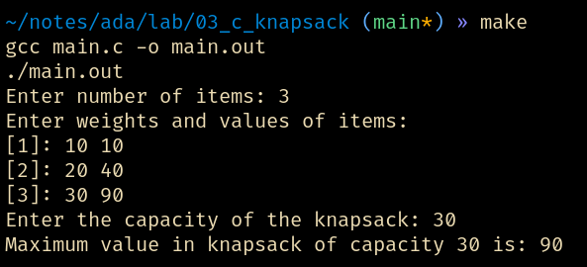

**LeetCode 509: Fibonacci Number**

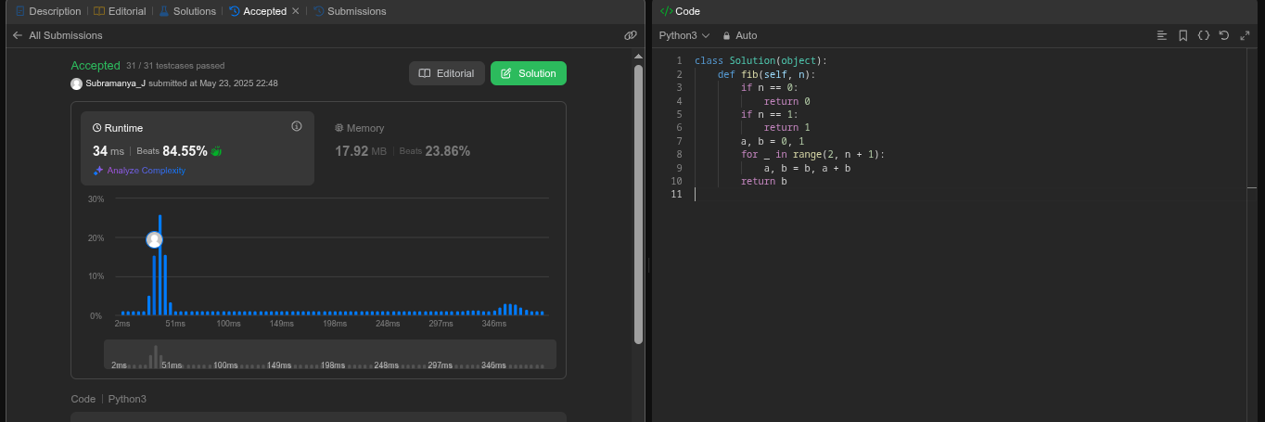

**Lab program 7:**

**Implement All Pair Shortest paths problem using Floyd’s algorithm.**

**#include <stdio.h>**

**#include <limits.h>**

**#include "graph.h"**

**void floyd(int **graph, int vertices) {**

**// Initialize: Convert 0s to INT_MAX, but not the diagonal**

**for(int i = 0; i < vertices; i++) {**

**for(int j = 0; j < vertices; j++) {**

**if(i != j && graph[i][j] == 0) {**

**graph[i][j] = INT_MAX;**

**}**

**}**

**}**

**// Floyd–Warshall core logic**

**for(int k = 0; k < vertices; k++) {**

**for(int i = 0; i < vertices; i++) {**

**for(int j = 0; j < vertices; j++) {**

**if (graph[i][k] != INT_MAX && graph[k][j] != INT_MAX &&**

**graph[i][k] + graph[k][j] < graph[i][j]) {**

**graph[i][j] = graph[i][k] + graph[k][j];**

**}**

**}**

**}**

**}**

**}**

**void graph_print(int **graph, int vertices) {**

**printf("\nDistance Matrix:\n");**

**for(int i = 0; i < vertices; i++) {**

**for(int j = 0; j < vertices; j++) {**

**if (graph[i][j] == INT_MAX)**

**printf("INF\t");**

**else**

**printf("%d\t", graph[i][j]);**

**}**

**putchar('\n');**

**}**

**putchar('\n');**

**}**

**int main() {**

**int edges, vertices;**

**int **graph = graph_create(&vertices, &edges);**

**printf("\nOriginal Graph:\n");**

**graph_print(graph, vertices);**

**floyd(graph, vertices);**

**printf("\nAfter Floyd's Algorithm:\n");**

**graph_print(graph, vertices);**

**return 0;**

**}**

**Output :**

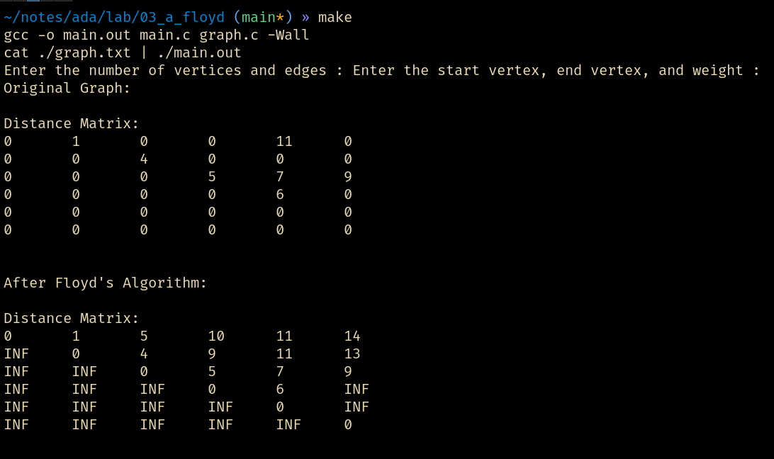**LeetCode 821: Shortest Distance to a Character**

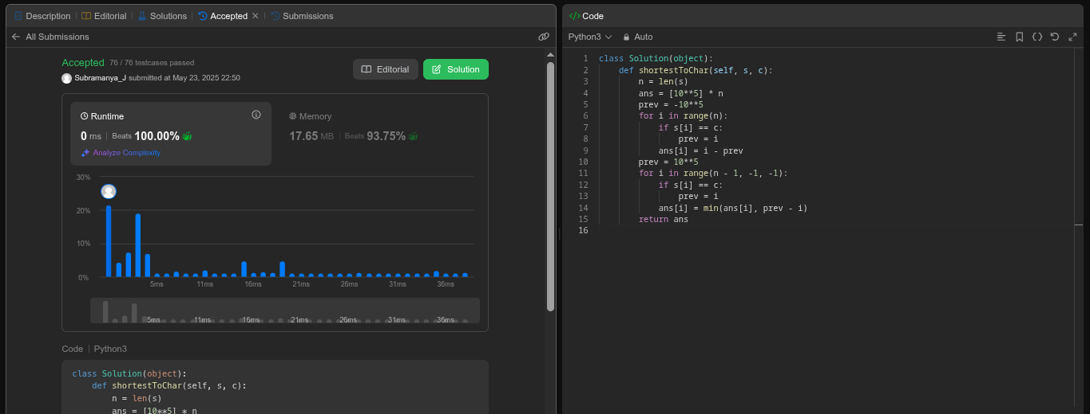

**Lab program 8:**

**Find Minimum Cost Spanning Tree of a given undirected graph using Prim’s algorithm.**

**// prim.c**

**#include "graph.h"**

**#include <stdio.h>**

**#include <limits.h>**

**int minKey(int key[], int mstSet[], int vertices) {**

**int min = INT_MAX, min_index;**

**for (int v = 0; v < vertices; v++) {**

**if (!mstSet[v] && key[v] < min) {**

**min = key[v], min_index = v;**

**}**

**}**

**return min_index;**

**}**

**void primMST(int **graph, int vertices) {**

**int parent[vertices]; // Stores constructed MST**

**int key[vertices]; // Used to pick minimum weight edge**

**int mstSet[vertices]; // To represent set of vertices included in MST**

**for (int i = 0; i < vertices; i++) {**

**key[i] = INT_MAX;**

**mstSet[i] = 0;**

**}**

**key[0] = 0; // First vertex is picked first**

**parent[0] = -1; // First node is always the root**

**for (int count = 0; count < vertices - 1; count++) {**

**int u = minKey(key, mstSet, vertices);**

**mstSet[u] = 1;**

**for (int v = 0; v < vertices; v++) {**

**if (graph[u][v] && !mstSet[v] && graph[u][v] < key[v]) {**

**parent[v] = u, key[v] = graph[u][v];**

**}**

**}**

**}**

**printf("\nEdge \tWeight\n");**

**for (int i = 1; i < vertices; i++) {**

**printf("%d - %d \t%d\n", parent[i], i, graph[i][parent[i]]);**

**}**

**}**

**int main() {**

**int edges, vertices, **graph = graph_create(&vertices, &edges);**

**primMST(graph, vertices);**

**return 0;**

**}**

**Output :**

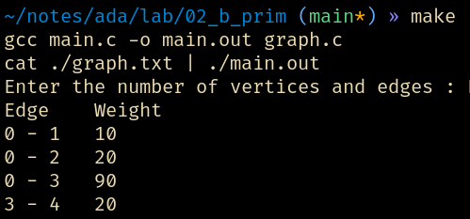

**Find Minimum Cost Spanning Tree of a given undirected graph using Kruskal’s algorithm.**

**// kruskal.c**

**#include "graph.h"**

**#include <stdio.h>**

**#include <stdlib.h>**

**struct Edge {**

**int src, dest, weight;**

**};**

**struct subset {**

**int parent;**

**int rank;**

**};**

**int find(struct subset subsets[], int i) {**

**if (subsets[i].parent != i) {**

**subsets[i].parent = find(subsets, subsets[i].parent);**

**}**

**return subsets[i].parent;**

**}**

**void Union(struct subset subsets[], int x, int y) {**

**int xroot = find(subsets, x);**

**int yroot = find(subsets, y);**

**if (subsets[xroot].rank < subsets[yroot].rank) {**

**subsets[xroot].parent = yroot;**

**} else if (subsets[xroot].rank > subsets[yroot].rank) {**

**subsets[yroot].parent = xroot;**

**} else {**

**subsets[yroot].parent = xroot;**

**subsets[xroot].rank++;**

**}**

**}**

**int compare(const void *a, const void *b) {**

**struct Edge *a1 = (struct Edge *) a;**

**struct Edge *b1 = (struct Edge *) b;**

**return a1->weight - b1->weight;**

**}**

**void kruskalMST(int **graph, int vertices) {**

**int edgeCount = 0;**

**struct Edge result[vertices];**

**struct Edge *edges = malloc(vertices * vertices * sizeof(struct Edge));**

**int edgeIndex = 0;**

**for (int i = 0; i < vertices; i++) {**

**for (int j = i + 1; j < vertices; j++) {**

**if (graph[i][j] != 0) {**

**edges[edgeIndex].src = i;**

**edges[edgeIndex].dest = j;**

**edges[edgeIndex].weight = graph[i][j];**

**edgeIndex++;**

**}**

**}**

**}**

**qsort(edges, edgeIndex, sizeof(edges[0]), compare);**

**struct subset *subsets = malloc(vertices * sizeof(struct subset));**

**for (int v = 0; v < vertices; v++) {**

**subsets[v].parent = v;**

**subsets[v].rank = 0;**

**}**

**for (int i = 0; i < edgeIndex; i++) {**

**int x = find(subsets, edges[i].src);**

**int y = find(subsets, edges[i].dest);**

**if (x != y) {**

**result[edgeCount++] = edges[i];**

**Union(subsets, x, y);**

**}**

**}**

**printf("\nEdge \tWeight\n");**

**for (int i = 0; i < edgeCount; i++) {**

**printf("%d - %d \t%d\n", result[i].src, result[i].dest, result[i].weight);**

**}**

**free(edges);**

**free(subsets);**

**}**

**int main() {**

**int edges, vertices, **graph = graph_create(&vertices, &edges);**

**kruskalMST(graph, vertices);**

**return 0;**

**}**

**Ouput :**

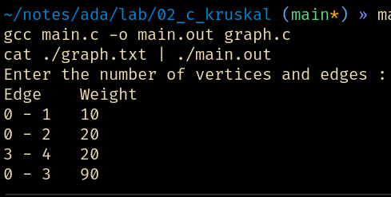

**Lab program 9:**

**Implement Fractional Knapsack using Greedy technique.**

**/\*\***

**\* Algorithm :**

**\* function fractionalKnapsack(W, value[], weight[], n):**

**items = []**

**for i from 0 to n-1:**

**ratio = value[i] / weight[i]**

**items.append((ratio, value[i], weight[i]))**

**sort items by ratio descending**

**totalValue = 0.0**

**for each (ratio, val, wt) in items:**

**if W >= wt:**

**totalValue += val**

**W -= wt**

**else:**

**totalValue += ratio * W**

**break**

**return totalValue**

**\*/**

**#include <stdio.h>**

**#include <stdlib.h>**

**#include <stdbool.h>**

**struct Item {**

**int weight;**

**int value;**

**float ratio;**

**};**

**int itemcmp(const void *x, const void *y) {**

**float ret = ((struct Item *) x )->ratio - ((struct Item *) y)->ratio;**

**if(ret > 0) {return -1;}**

**if(ret < 0) {return 1;}**

**return 0;**

**}**

**struct Item *get_items(int *n) {**

**printf("Enter the number of items : ");**

**scanf("%d", n);**

**struct Item *arr = calloc(*n, sizeof(struct Item));**

**printf("Enter the weight and value of each item : \n");**

**for(int i = 0; i < *n; i++) {**

**printf("Item %d : ", i);**

**scanf("%d %d", &arr[i].weight, &arr[i].value);**

**arr[i].ratio = (float) arr[i].value / arr[i].weight;**

**}**

**qsort(arr, *n, sizeof(struct Item), itemcmp);**

**return arr;**

**}**

**float calculate_max(struct Item *arr, int n, int max) {**

**float total = 0;**

**for(int i = 0; i < n; i++) {**

**if(max == 0) {**

**break;**

**}**

**else if(arr[i].weight < max) {**

**total += arr[i].value;**

**max -= arr[i].weight;**

**}**

**else if(arr[i].weight > max) {**

**total += arr[i].ratio * max;**

**break;**

**}**

**}**

**return total;**

**}**

**int main() {**

**int n, max;**

**printf("Enter the maximum capacity : ");**

**scanf("%d", &max);**

**struct Item * arr = get_items(&n);**

**float max_val = calculate_max(arr, n, max);**

**printf("Maximum value : %f\n", max_val);**

**free(arr);**

**return 0;**

**}**

**Output :**

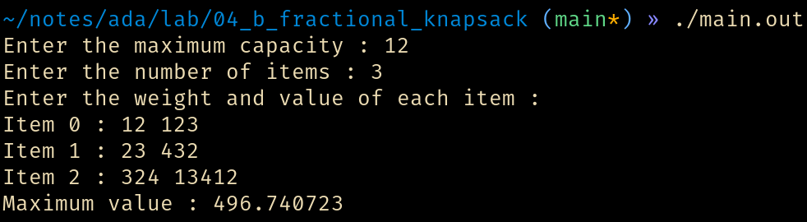

**LeetCode 1903: Largest Odd Number in a String**

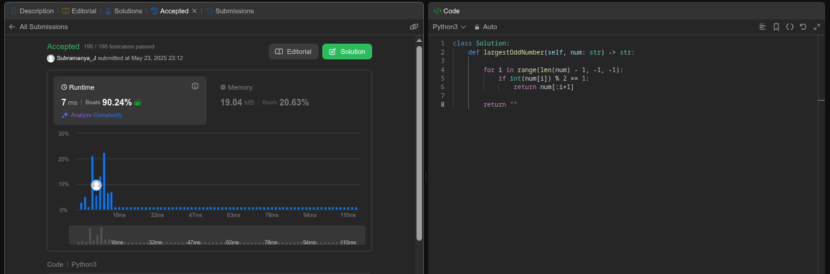

**Lab program 10:**

**From a given vertex in a weighted connected graph, find shortest paths to other vertices using Dijkstra’s algorithm.**

**#include <stdio.h>**

**#include <limits.h>**

**#include <stdlib.h>**

**#include <stdbool.h>**

**#include "graph.h"**

**int min_index(int dist[], bool visited[], int n) {**

**int min_in = -1, min = INT_MAX;**

**for(int i = 0; i < n; i++) {**

**if (!visited[i]**

**&& dist[i] < min) {**

**min = dist[i];**

**min_in = i;**

**}**

**}**

**return min_in;**

**}**

**void dijkstra(int **graph, int vertices, int start) {**

**bool visited[vertices];**

**int dist[vertices];**

**for(int i = 0; i < vertices; i++) {**

**visited[i] = false;**

**dist[i] = INT_MAX;**

**}**

**dist[start] = 0;**

**int curr;**

**for(int i = 0; i < vertices - 1; i++) {**

**curr = min_index(dist, visited, vertices);**

**visited[curr] = true;**

**for(int i = 0; i < vertices; i++) {**

**if (**

**!visited[i]**

**&& graph[curr][i]**

**&& dist[curr] != INT_MAX**

**&& dist[curr] + graph[i][curr] < dist[i]**

**) {**

**dist[i] = dist[curr] + graph[curr][i];**

**}**

**}**

**}**

**for(int i = 0; i < vertices; i++) {**

**printf("%d -> %d : %d\n", start, i, dist[i]);**

**}**

**}**

**int main() {**

**int vertices, edges,**

**\*\*graph = graph_create(&vertices, &edges);**

**printf("Enter the starting vertex : ");**

**int start;**

**scanf("%d", &start);**

**dijkstra(graph, vertices, start);**

**graph_free(graph, vertices);**

**return 0;**

**}**

**Output :**

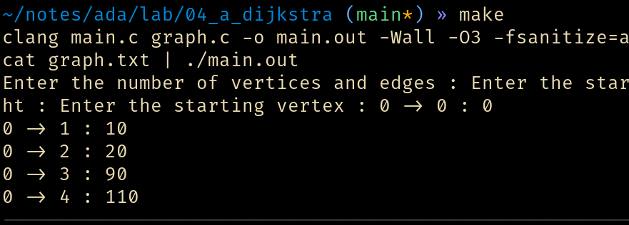

**Lab program 11:**

**Implement “N-Queens Problem” using Backtracking.**

**#include <stdio.h>**

**#include <stdlib.h>**

**#include <math.h>**

**int x[20], count = 1;**

**void queens(int k, int n);**

**int place(int k, int j);**

**int main() {**

**int n;**

**printf("\nEnter the number of queens to be placed: ");**

**scanf("%d", &n);**

**if (n < 4) {**

**printf("No solutions for N = %d\n", n);**

**} else {**

**queens(1, n);**

**}**

**return 0;**

**}**

**void queens(int k, int n) {**

**int i, j;**

**for (j = 1; j <= n; j++) {**

**if (place(k, j)) {**

**x[k] = j;**

**if (k == n) {**

**printf("\nSolution %d:\n", count);**

**count++;**

**for (i = 1; i <= n; i++) {**

**printf("\tRow %d <--> Column %d\n", i, x[i]);**

**}**

**} else {**

**queens(k + 1, n);**

**}**

**}**

**}**

**}**

**int place(int k, int j) {**

**int i;**

**for (i = 1; i < k; i++) {**

**if ((x[i] == j) || (abs(x[i] - j)) == abs(i - k)) {**

**return 0;**

**}**

**}**

**return 1;**

**}**

**Output :**

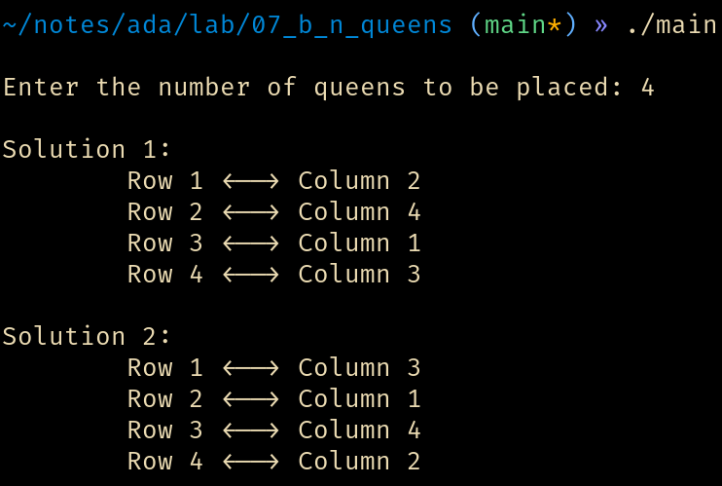

**Auxillary file graph.c**

**// graph.c**

**#include "graph.h"**

**#include <stdlib.h>**

**#include <stdio.h>**

**int **graph_create(int *vertices, int *edges) {**

**printf("Enter the number of vertices and edges : ");**

**scanf("%d %d", vertices, edges);**

**int **arr = calloc(*vertices, sizeof(int *));**

**for(int i = 0; i < *vertices; i++) {**

**arr[i] = calloc(*vertices, sizeof(int));**

**}**

**int start, end, weight;**

**printf("Enter the start vertex, end vertex, and weight : ");**

**for(int i = 0; i < *edges; i++) {**

**scanf("%d %d %d", &start, &end, &weight);**

**arr[start][end] = arr[end][start] = weight;**

**}**

**return arr;**

**}**